# PeopleSafe - Payment - Unauthorized Payment Transaction

Reminders

Payment Dispute Issues

Processing a Payment Reversal Request

Resolution Time

Related Documents

**Description:** Process to be used when a call is received regarding an unauthorized electronic payment transaction appearing on the caller’s billing statement. This situation requires that a reversal of charge be completed for the caller.

|  |
| --- |
| Reminders |

 Do not delete the method of payment until **after** a refund has been processed.

Under no circumstance is it appropriate to list full credit card numbers or E-check routing and account numbers in any comments field. This includes RM task comments/notes and stop-see comments. Credit card numbers and E-check routing and account numbers may only be entered in system specified credit card number/E-check routing and account number fields. All comment fields are periodically checked for compliance. Users who fail to abide by policy may be subject to disciplinary action.

**Notes:**

* Effective February 16, 2019, the Credit Card Field (Last 4 digits) will only allow for the last 4 digits of credit card.
* It is important to verify the credit card being used is listed as a payment method on the beneficiary’s account.

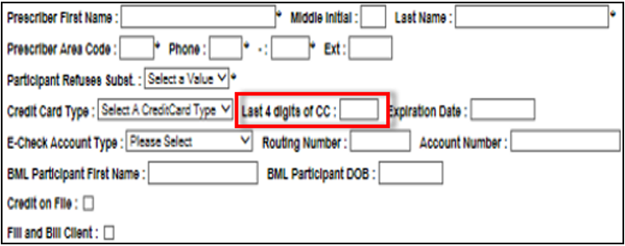

If a new card is needed, refer to [Payment Maintenance Add, Edit and Remove (Credit Card and eCheck) (010987)](https://thesource.cvshealth.com/nuxeo/thesource/#!/view?docid=b0d1693e-3ebd-45e7-811a-adbe7e2c9f83). Then the last 4 digits of the new card can be notated.

Top of the Document

|  |
| --- |
| Payment Dispute Issues |

When an exclusive payment account is selected/provided as the form of payment for an order, any outstanding balance will be included in the payment. This occurs regardless of whose orders generated the outstanding balance, because our system does not track outstanding balances by family member. The only exception to this is when a member places an order through Customer Care, in which CCRs can specify whether any portion of an outstanding balance is included.

Top of the Document

|  |
| --- |
| Processing a Payment Reversal Request |

If CCR receives a call regarding an unauthorized payment transaction that was processed, and which appears on the caller's billing statement.

Perform the following steps to process a Payment Reversal Request:

|  |  |  |
| --- | --- | --- |
| **Step** | **Action** | |
| **1** | Obtain the following:   * Date of charges appearing on statement * Amount of charges * Credit card or electronic check information | |
| **2** | Confirm information with the caller based on the payment type: | |
| **If…** | **Then obtain…** |
| Credit Card | * Credit card type * Last 4 digits of credit card * Credit card expiration date |
| Electronic Check | * Account type (checking or savings) * Routing Number * Account Number |
| **3** | Create a task in RM as follows:   * **Task Category:**  Billing/Payment * **Task Type:**  Unauthorized Payment Transaction * **Queue:** Finance - Northbrook   **Note****:** Advise the caller that a Payment Reversal Request has been submitted, and that a resolution will be provided within 5 business days. | |

Top of the Document

|  |
| --- |
| Resolution Time |

Up to 5 business days

Top of the Document

|  |
| --- |
| Related Documents |

[Log Activity/Capture Activity Codes (005164)](https://thesource.cvshealth.com/nuxeo/thesource/#!/view?docid=bdac0c67-5fee-47ba-a3aa-aab84900cf78)

[Customer Care Abbreviations, Definitions, and Terms Index (017428)](https://thesource.cvshealth.com/nuxeo/thesource/#!/view?docid=c1f1028b-e42c-4b4f-a4cf-cc0b42c91606)

**Parent Document:** [CALL 0049 Customer Care Internal and External Call Handling](https://policy.corp.cvscaremark.com/pnp/faces/DocRenderer?documentId=CALL-0049)

Top of the Document

Not To Be Reproduced or Disclosed to Others Without Prior Written Approval

**ELECTRONIC DATA = OFFICIAL VERSION / PAPER COPY = INFORMATIONAL ONLY**